- Network Reconfiguration: Include the following screenshots:
  - Network diagram
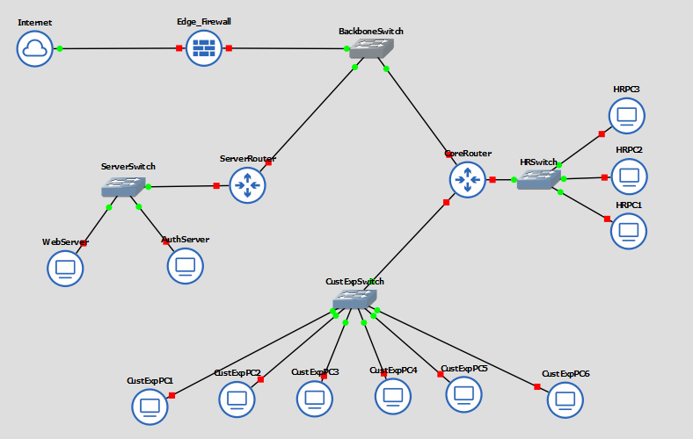
  - Port assignment and VLAN assignment for each switch
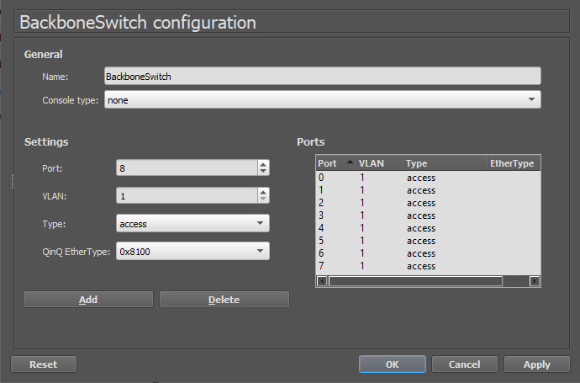
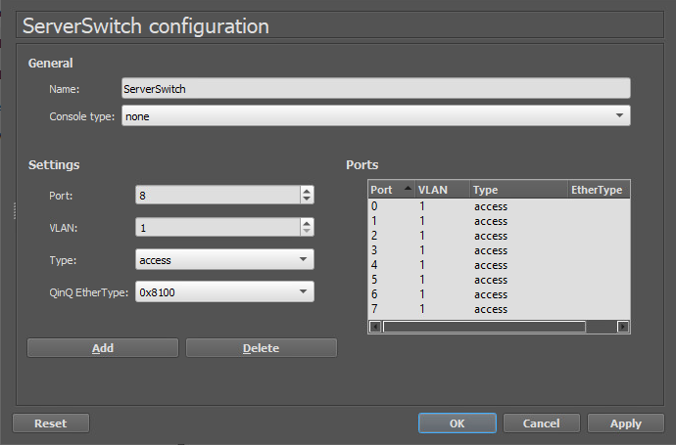
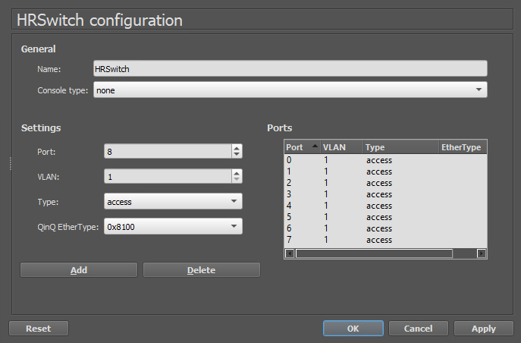
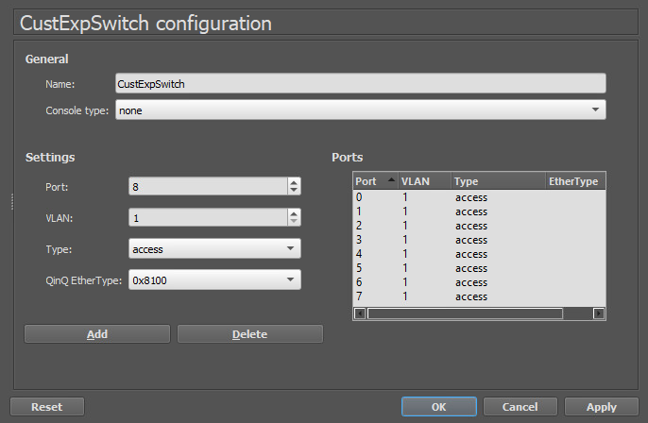
- Traffic Flow Configuration: Include screenshots of the following:
  - Configure a firewall rule to allow port 80 HTTP from the WAN to the Web server.
  - Configure a firewall rule to allow port 443 HTTPS from the WAN to the Web server.
  - Configure a firewall rule to block port 80 HTTP from the WAN to any other system.
  - Configure a firewall rule to block port 443 HTTPS from the WAN to any other system.
- Organizational Security Strategy
  - Explain how the security posture of the organization has been improved by the restructuring.
    - The restructuring made the organization’s network a lot more secure and easier to control. By setting up firewall rules that only allow web traffic on ports 80 and 443 to reach the web server, outside access is limited to what’s actually needed. Everything else coming from the WAN is blocked, which cuts down the chances of any unwanted traffic or attacks getting through. The new setup also organizes how systems connect and communicate, keeping things more contained and reducing risks across the network. Overall, the company now has a stronger security foundation with better visibility and protection against threats.
  - Describe how the tenets of the CIA triad (confidentiality, integrity, and availability) are affected by the restructuring.
    - The restructuring strengthens all three parts of the CIA triad. Confidentiality is improved because the firewall now blocks outside users from reaching internal systems or data they shouldn’t access, keeping sensitive information protected. Integrity benefits from the controlled traffic flow since the firewall helps prevent altered or malicious data from entering the network, ensuring that information stays accurate and reliable. Availability also improves because allowing only necessary traffic keeps the network running efficiently without being slowed down or interrupted by unwanted or harmful requests. Together, these changes make the network more secure and balanced while maintaining proper access for legitimate users.

